CDAC MUMBAI

Concepts of Operating System

Assignment 2

**Part A**

What will the following commands do?

* echo "Hello, World!"

>> It will print Hello World.

* name="Productive"

>> Variable will hold String.

* touch file.txt

>> It will create a file in text format.

* ls -a

>> It will list all the files and directories from the current directory including hidden files

* rm file.txt

>> It will remove the file.

* cp file1.txt file2.txt

>> It will copy the contents from one file to another file ( if the file doesn’t exist it will create a new file )

* mv file.txt /path/to/directory/

>> It will move the file to a specific directory

* chmod 755 script.sh

>> It will change the file permission; for the owner, it will give read, write, execute whereas for groups and others, it will read and write.

* grep "pattern" file.txt

>> It will print lines containing “pattern” word.

* kill PID

>> It is used to kill the specific process with processID

* mkdir mydir && cd mydir && touch file.txt && echo "Hello, World!" > file.txt && cat file.txt

>>

Mkdir mydir: it will create a directory name mydir

Cd mydir: we will move into mydir directory

touch file.txt: This command will create a file in txt format

echo “Hello World!” : this command is written in file.txt

cat file.txt: It will print Hello World

* ls -l | grep ".txt"

>> It will display all the files ending with .txt extension

* cat file1.txt file2.txt | sort | uniq

>> it prints the contents from both the file, sort will sort the content alphabetically and uniq will remove adjacent duplicates

* ls -l | grep "^d"

>> it will display list if file and directory along with its permission and other information and grep command will search files and directory starting from d character

* grep -r "pattern" /path/to/directory/

>> It will print lines containing “pattern” words.

* cat file1.txt file2.txt | sort | uniq –d

>> it prints the contents from both the file, sort will sort the content alphabetically and uniq -d will display duplicates lines only

* chmod 644 file.txt

>> it changes permission for owner to read and write where for others and group to read only

* cp -r source_directory destination_directory

>> it copies content from source file to destination file recursively

* find /path/to/search -name "*.txt"

>> it finds and lists all files with the .txt extension

* chmod u+x file.txt

>> it give execute permission to user/owner

* echo $PATH

>> it print current path

**Part B**

Identify True or False:

1. ls is used to list files and directories in a directory.

True

1. mv is used to move files and directories.

True

1. cd is used to copy files and directories.

False

1. pwd stands for "print working directory" and displays the current directory.

True

1. grep is used to search for patterns in files.

True

1. chmod 755 file.txt gives read, write, and execute permissions to the owner, and read and execute permissions to group and others.

False only read and write to group and others

1. mkdir -p directory1/directory2 creates nested directories, creating directory2 inside directory1 if directory1 does not exist.

True

1. rm -rf file.txt deletes a file forcefully without confirmation.

True

Identify the Incorrect Commands:

1. chmodx is used to change file permissions

Incorrect - correct would be chmod.

1. cpy is used to copy files and directories.

Incorrect- correct : cp

1. mkfile is used to create a new file.

Incorrect- correct : touch

1. catx is used to concatenate files.

Incorrect- correct : cat

1. rn is used to rename files.

Incorrect- correct : mv

**Part C**

Question 1: Write a shell script that prints "Hello, World!" to the terminal.



Question 2: Declare a variable named "name" and assign the value "CDAC Mumbai" to it. Print the

value of the variable.



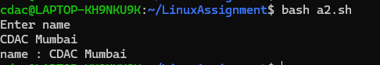

Question 3: Write a shell script that takes a number as input from the user and prints it.

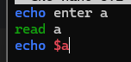

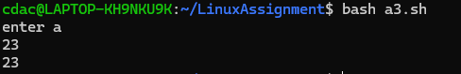

Question 4: Write a shell script that performs addition of two numbers (e.g., 5 and 3) and prints the

result.

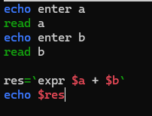

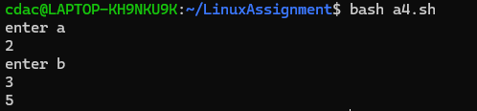

Question 5: Write a shell script that takes a number as input and prints "Even" if it is even, otherwise

prints "Odd".

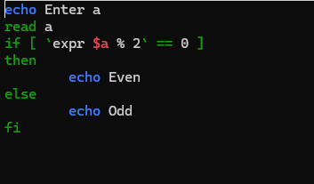

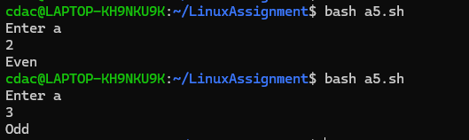

Question 6: Write a shell script that uses a for loop to print numbers from 1 to 5.

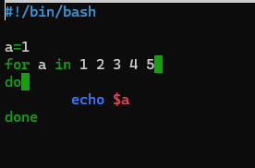

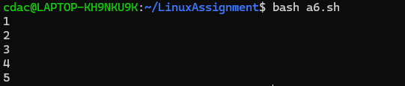

Question 7: Write a shell script that uses a while loop to print numbers from 1 to 5.

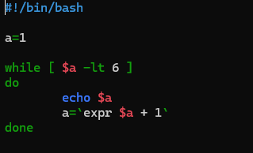

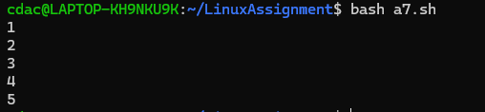

Question 8: Write a shell script that checks if a file named "file.txt" exists in the current directory. If it

does, print "File exists", otherwise, print "File does not exist".

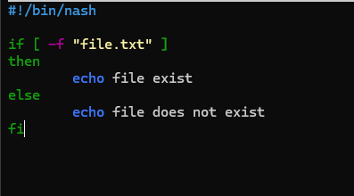



Question 9: Write a shell script that uses the if statement to check if a number is greater than 10 and

prints a message accordingly.

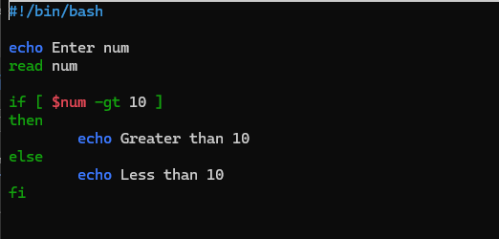

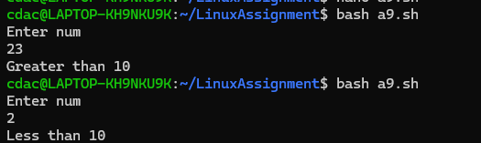

Question 10: Write a shell script that uses nested for loops to print a multiplication table for numbers

from 1 to 5. The output should be formatted nicely, with each row representing a number and each

column representing the multiplication result for that number.

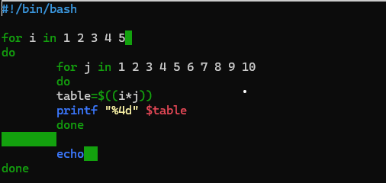

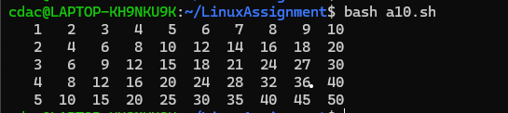

Question 11: Write a shell script that uses a while loop to read numbers from the user until the user enters a negative number. For each positive number entered, print its square. Use the break statement to exit the loop when a negative number is entered.

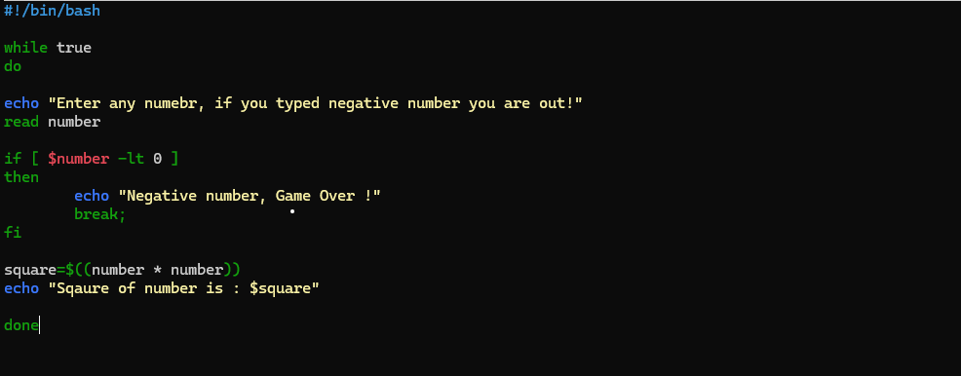

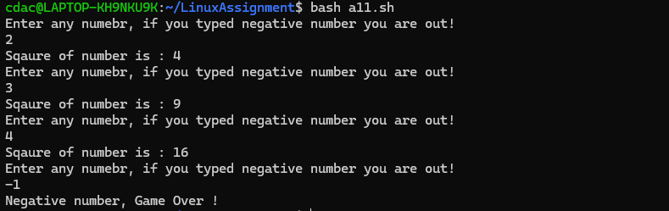

**Part E**

1. Consider the following processes with arrival times and burst times:

| Process | Arrival Time | Burst Time |

|---------|--------------|------------|

| P1 | 0 | 5 |

| P2 | 1 | 3 |

| P3 | 2 | 6 |

Calculate the average waiting time using First-Come, First-Served (FCFS) scheduling.

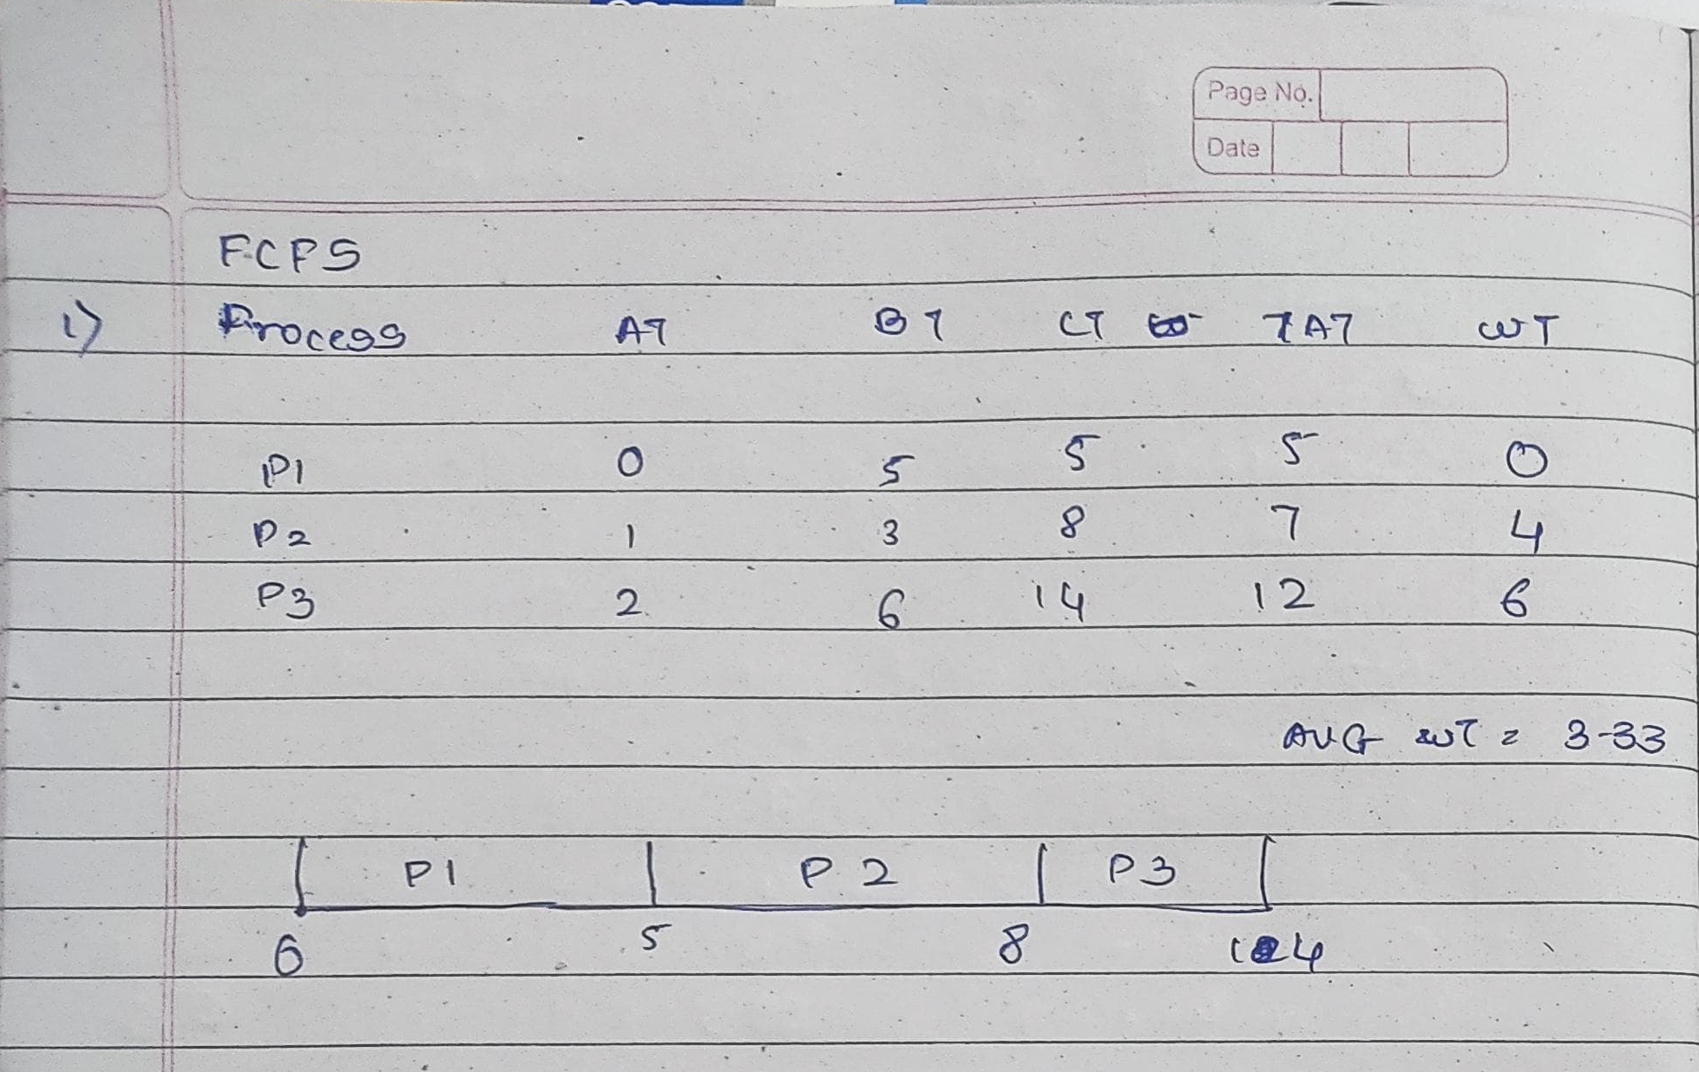

2. Consider the following processes with arrival times and burst times:

| Process | Arrival Time | Burst Time |

|---------|--------------|------------|

| P1 | 0 | 3 |

| P2 | 1 | 5 |

| P3 | 2 | 1 |

| P4 | 3 | 4 |

Calculate the average turnaround time using Shortest Job First (SJF) scheduling.

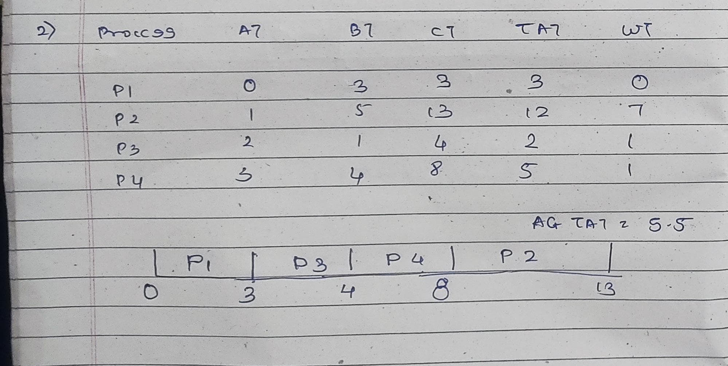

3. Consider the following processes with arrival times, burst times, and priorities (lower number

indicates higher priority):

| Process | Arrival Time | Burst Time | Priority |

|---------|--------------|------------|----------|

| P1 | 0 | 6 | 3 |

| P2 | 1 | 4 | 1 |

| P3 | 2 | 7 | 4 |

| P4 | 3 | 2 | 2 |

Calculate the average waiting time using Priority Scheduling.

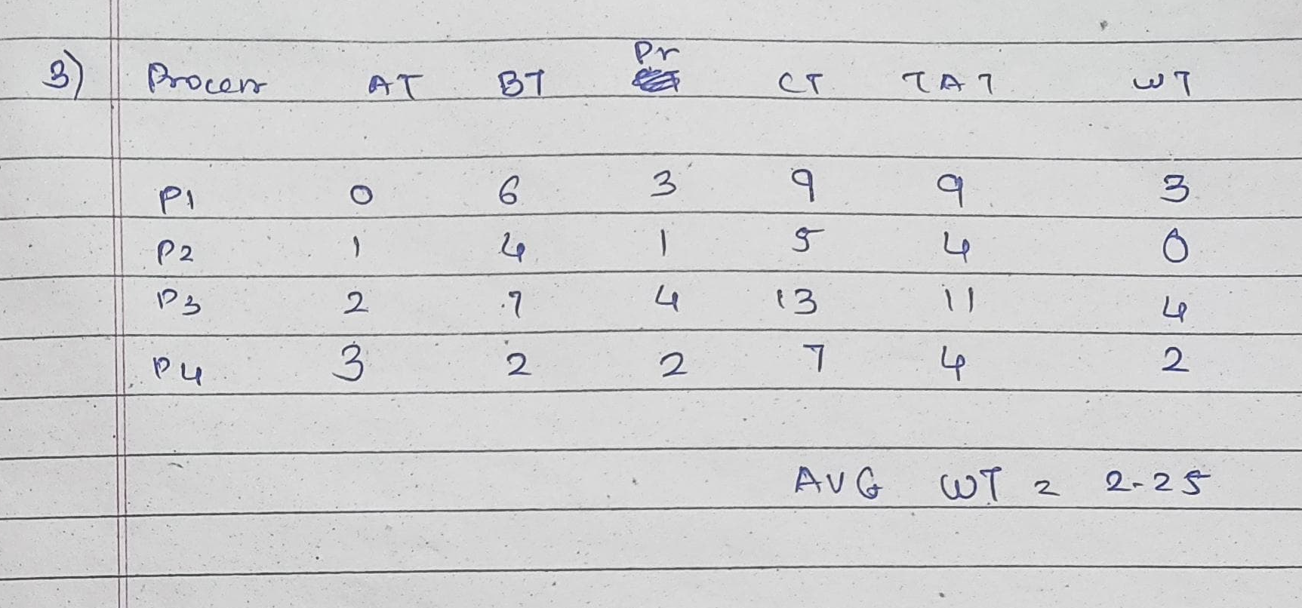

4. Consider the following processes with arrival times and burst times, and the time quantum for

Round Robin scheduling is 2 units:

| Process | Arrival Time | Burst Time |

|---------|--------------|------------|

| P1 | 0 | 4 |

| P2 | 1 | 5 |

| P3 | 2 | 2 |

| P4 | 3 | 3 |

Calculate the average turnaround time using Round Robin scheduling.

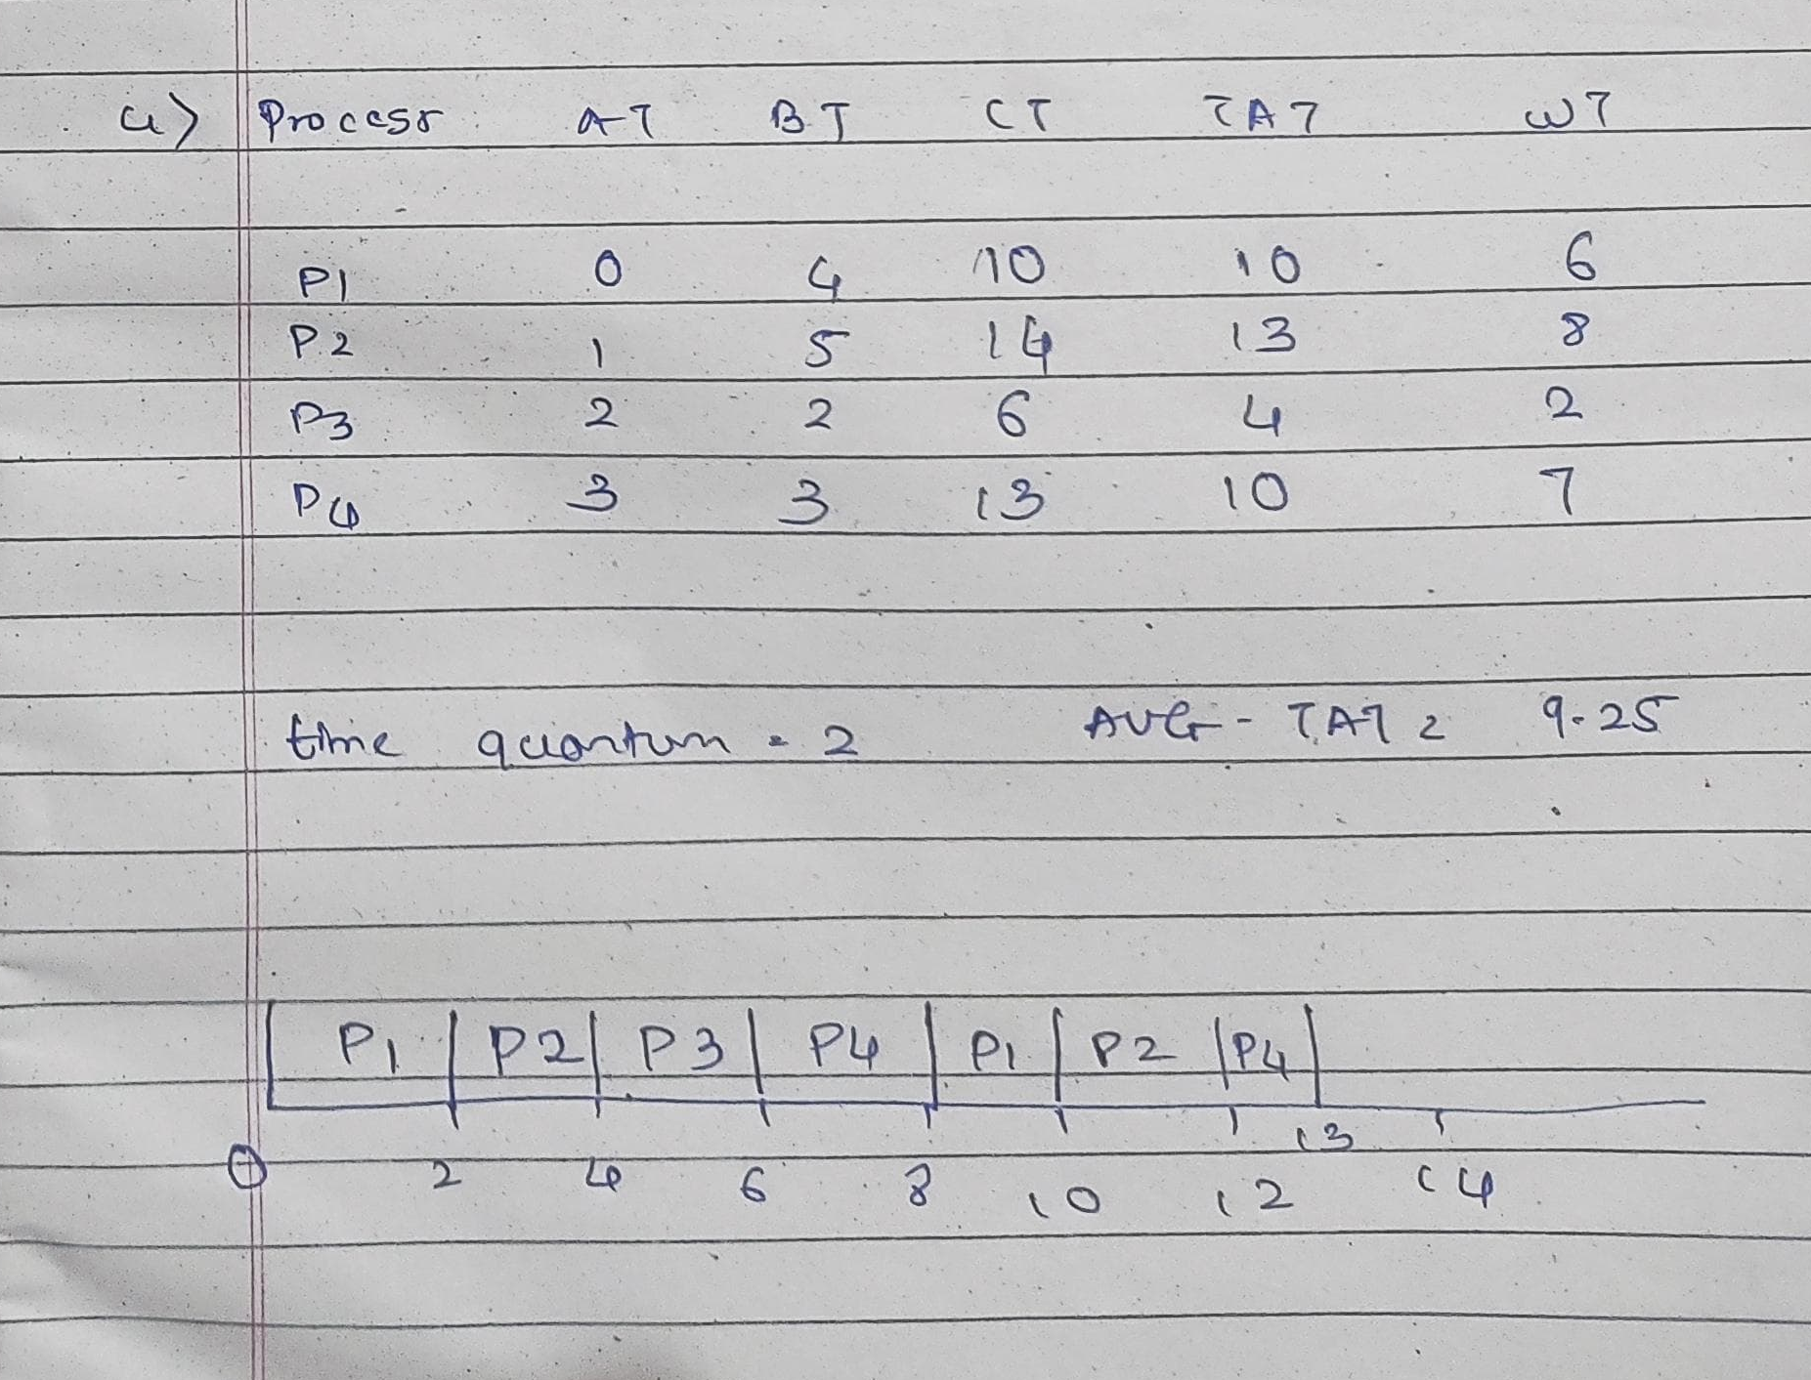

5. Consider a program that uses the fork() system call to create a child process. Initially, the parent

process has a variable x with a value of 5. After forking, both the parent and child processes

increment the value of x by 1.

What will be the final values of x in the parent and child processes after the fork() call?

Answer : Parent formula = 2 ^ (n) = 32 + 1 = 33

Child formula = ( 2 ^ 5 ) -1 = 31 + 1 = 32